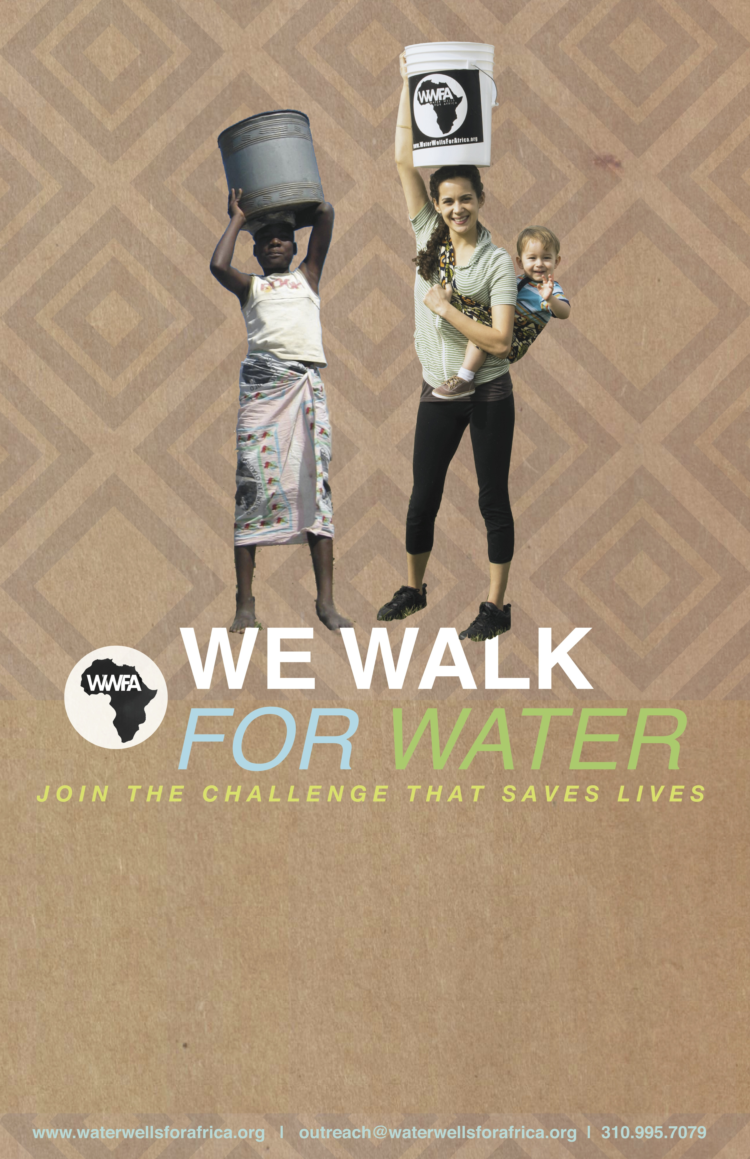
ADD TEXT ABOUT YOUR EVENT AND GET YOUR COMMUNITY EXCITED!

Don’t forget to add:
- (PERSONALIZED GROUP NAME, if any)
- WHEN
- WHERE
- CONTACT TO PARTICIPATE

When you are finished with this poster, “Save As” a PDF and talk to your local copy center about printing costs.

- WWFA is not responsible for printing costs and cannot be held responsible for the placement of these posters.
- Make sure you have permission to place posters on public or private property AND then … go wild!

